Study Abroad as a Community College Student with a Disability



# Dear Students,

Studying abroad is an amazing experience! If you want to learn a language or be part of a new culture, there is no better way to do these things.

This short guide has some scholarships that you may apply for. It is not a list of every single study abroad program. Think of it as a starting point.

After reading this booklet, talk to a trusted professor or advisor about your interest in studying abroad. They can help you with your essays and even write you a strong letter of recommendation.

I wish you the best of luck on your journey!

Sincerely,

Alexandra

(Note: “accommodations” in this booklet refers to personalized support related to your disability)

Sample List of Disability Accommodations Abroad

#### This list was provided by Amideast. | Every program is different so ask about all of them!

* Ensuring elevator access in student housing and providing measurements upon request
  + Alternatively, where an elevator is not suitable or available, are ground floor spaces/rooms available?
* Ensuring digital documents are available in digitally accessible formats
* Ensuring pre-recorded webinars/videos used in pre-departure orientation have subtitles and/or transcripts
* Adjusting seating in any meeting space to ensure participants with visual or auditory impairments can access the speaker/their peers
* Employing transportation for excursions which is wheelchair accessible
* Facilitating the contracting of local personal assistants/nurses/care providers
  + Or, providing program housing that allows for participants to bring their own personal assistant
* Providing sign language interpreters
* Modifying attendance policy (missing class due to medical appointments)
* Allowing for the use of audio/visual recording tools during lectures and panel discussions, with consent from the guest speakers
* Allowing for the use of notetaking tools
* If there are pre-departure reading and response assignments, does the program accept responses in any format (text, video, audio note)?
* In person and virtual mental health counseling
* Adjusting testing and/or classroom environments for academic accommodations like extended time, private testing rooms, draft reviews, use of computers and/or transcription devices during test taking/in class assignments, and other situations

The Benjamin A. Gilman International Scholarship

#### Official Website: [www.gilmanscholarship.org](http://www.gilmanscholarship.org) | The scholarship is called “Gilman” for short

If you are a student who receives a Pell Grant as part of your financial aid, you are eligible for this.

The way that Gilman works is that you will meet with an advisor to pick an eligible study program.

Next, you will write three or more essays responding to the prompts. Get a trusted professor or advisor to read over them for you. You got this!

Sometimes, students think that Gilman itself is a study program with a school abroad, but it is not. Gilman simply funds and supports the program that you pick. It offers a lot of choice and options.

When it comes to accommodations, this depends on your program. Some universities have more accessibility features and staff than others.

It is up to you to research and learn about the places you are thinking about going to. If you need help, ask your advisor and look at Gilman’s website. You can even email or call their office!

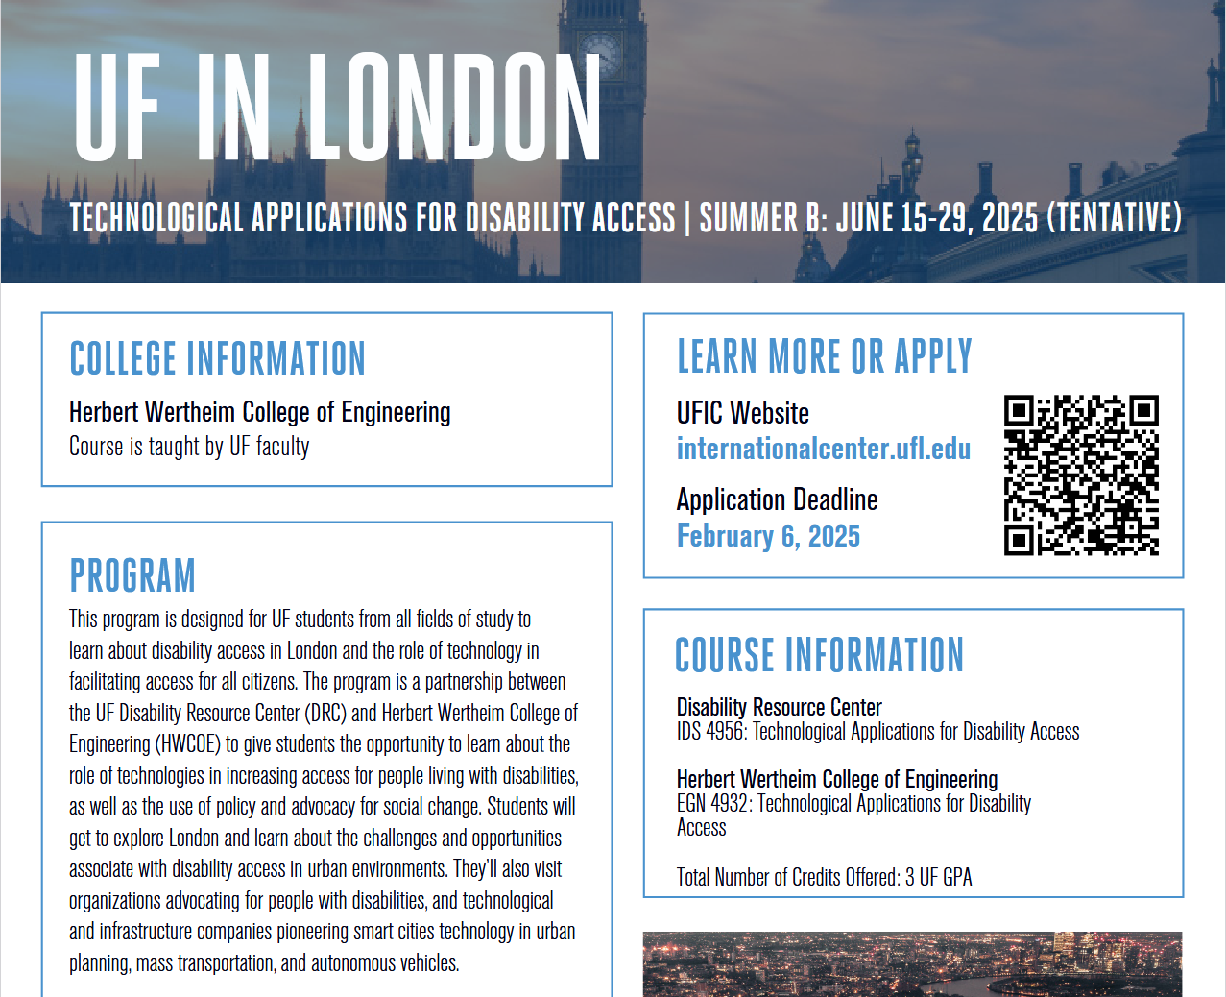Example of a Study Abroad Program in London, UK

Above is a screenshot of a program tailored to students with disabilities. It is important to ask the hosting university about what services they can give you. Don’t forget to speak up for yourself!

Critical Language Scholarship (CLS): focusing on CLS Spark

#### Official Website: [www.clscholarship.org](http://www.clscholarship.org) | You can study either in the country or online.

Sometimes, students may not be able to or want to go abroad right away. This is where CLS Spark comes in. If you are curious about languages, then keep on reading! There are 5 languages available.

They are Arabic, Chinese, Korean, Japanese and Russian. You will study for 8 weeks during the summer by attending classes over video call.

A major perk of CLS Spark is that *those who complete the course are eligible for special priority* when they apply for the CLS Program overseas.

The teachers have frequent office hours and are happy to work with CLS staff to make sure that you can get the accommodations you need.

Classes are typically 2 hours a day, 5 days a week. For the CLS Program overseas, the schedule is similar. Before you fly out to your host country, you will complete a medical history packet so that staff can accommodate you properly (example: housing and food, plus access to your prescription meds).

Example of a CLS class during 2021. CLS Spark is very similar.

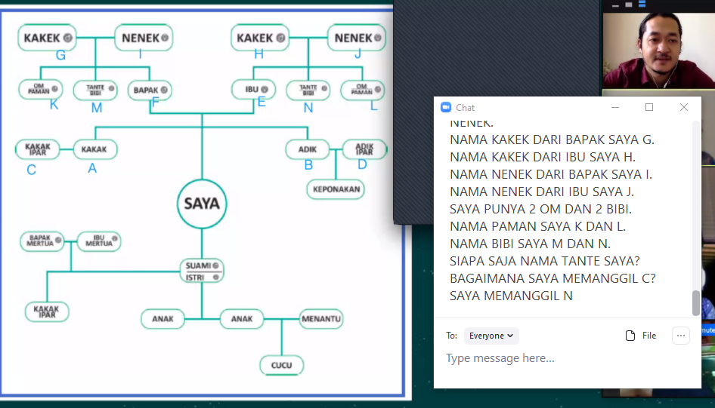The picture above is a screenshot from my time on CLS’ Indonesian program in 2021. During the pandemic, class became fully online. This was the pilot program for what’s now known as CLS Spark.

Although Indonesian is not offered as part of CLS Spark, it is one of the languages where no experience is needed to go study it abroad.

Other languages that welcome new learners are: Turkish, Persian, Hindi, Urdu, Swahili and Portuguese. The goal of CLS is to promote the study of less commonly taught languages.

Amideast’s Community and Social Engagement Program

#### Official Website: [www.amideast.org](https://www.amideast.org/our-work/education-abroad-in-the-mena/abroad-programs/summer-programs/community-and-social-entrepreneurship) | This 8-day program in Tunisia is for students like you!

Amideast is an organization connecting America to the Middle East through educational programs.

The Community and Social Engagement Program is an 8-day guided introduction to Tunis, Tunisia. You will go to presentations and panel discussions.

Also, there will be tours and community service opportunities. You can meet with Tunisian students and community leaders, who will talk about issues and topics related to Tunisia and North Africa.

Unlike Gilman and CLS, Amideast accepts Green Card holders into its program. They may also be able to help with the cost of getting a passport.

If studying abroad feels daunting and impossible, this program may be a great option. It’s short and it’s only for community college students.

Accommodations may be harder to find in Tunisia. If you’re interested in this program, communicate with Amideast to see what they can provide you.

(Turn the page for 2 pictures. Credit to Amideast.)

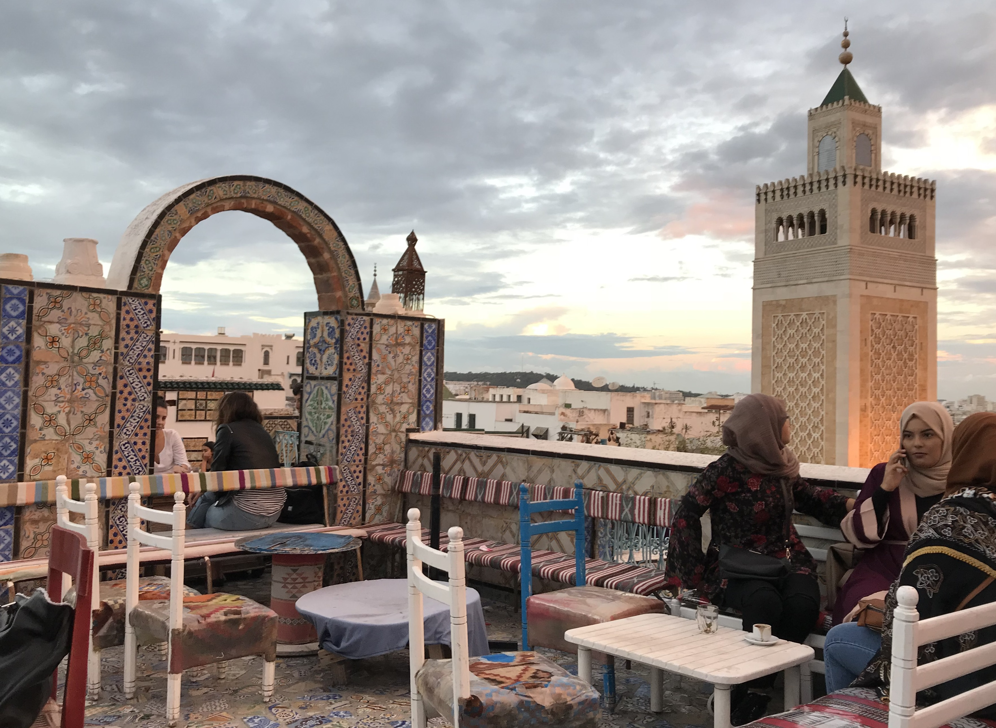A Final Word to You, the Student

Thank you for reading my booklet about study abroad! I hope you found it helpful and concise.

Making this booklet would not have been possible without the support of the National Clearinghouse on Disability and Exchange (NCDE) as part of Mobility International USA (MIUSA).

NCDE and MIUSA provide strategies, support and programming to increase the number of students with disabilities who are studying/interning abroad

I am honored to have been chosen to be a part of their Summer 2025 Externship. It has been fun!

To learn more about this organization please visit their website at <https://miusa.org/ncde/>

May you always feel empowered on your journey!